EXERCISE 1: INVENTORY MANAGEMENT SYSTEM
AIM
To develop an Inventory Management System using appropriate data structures and algorithms for efficient storage, retrieval, updating, and deletion of product information.
_________________________________________________________________________________
UNDERSTANDING THE PROBLEM
Inventory systems handle large volumes of data. If products are not stored efficiently, operations such as searching and updating become slow and affect overall system performance.
Importance of Data Structures and Algorithms
- Efficient data storage and retrieval.
- Faster search and update operations.
- Better scalability for large inventories.
- Reduced execution time and memory usage.
_________________________________________________________________________________
Data Structure | Best For | Time Complexity (Search) | Time Complexity (Insert/Delete)
ArrayList | Simple storage, sequential access | O(n) (linear search) | O(1) (end), O(n) (middle)
HashMap | Fast lookup by key | O(1) average case | O(1) average case
TreeMap | Sorted storage | O(log n) | O(log n)
HashSet | Preventing duplicate entries | O(1) average case | O(1) average case
SUITABLE DATA STRUCTURES
IMPLEMENTATION
Product.java
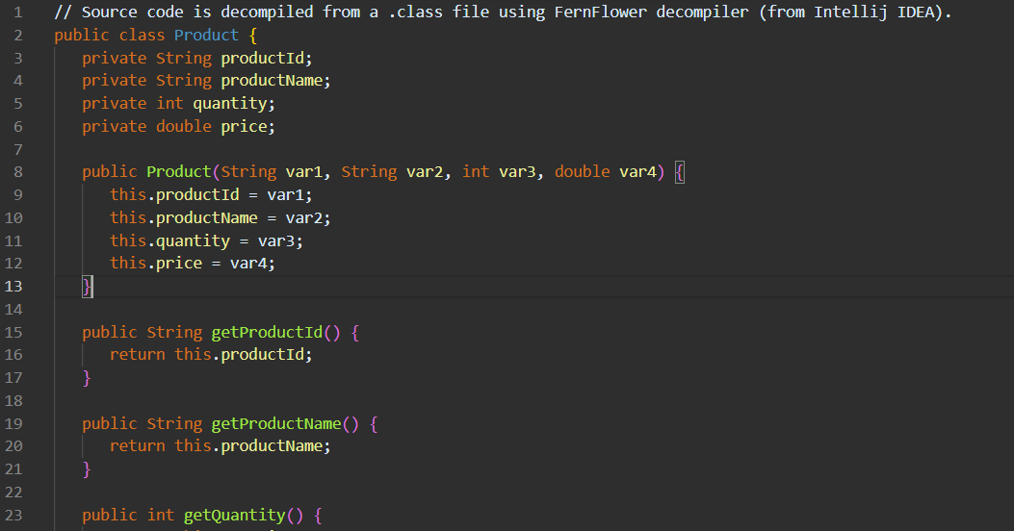

IventoryManager.java
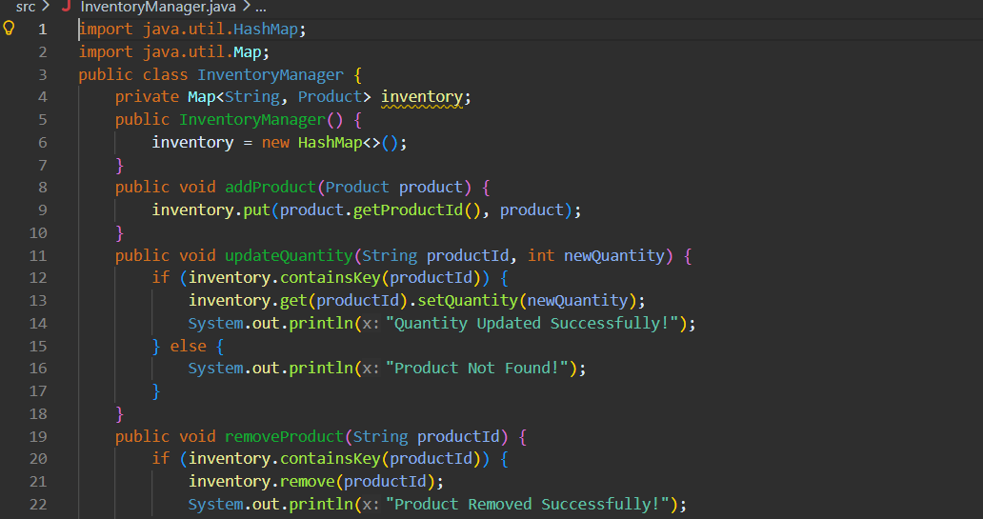
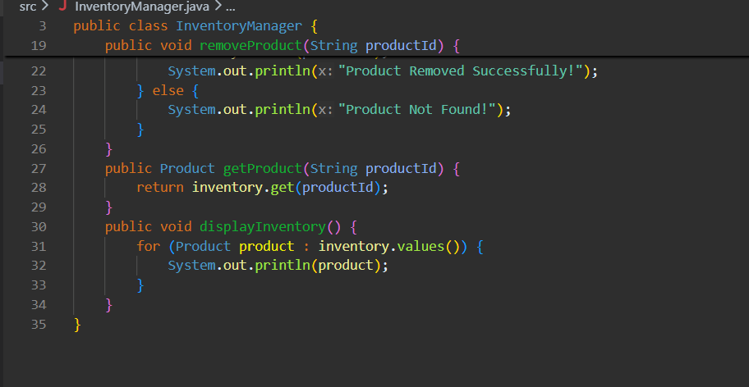

Main.java
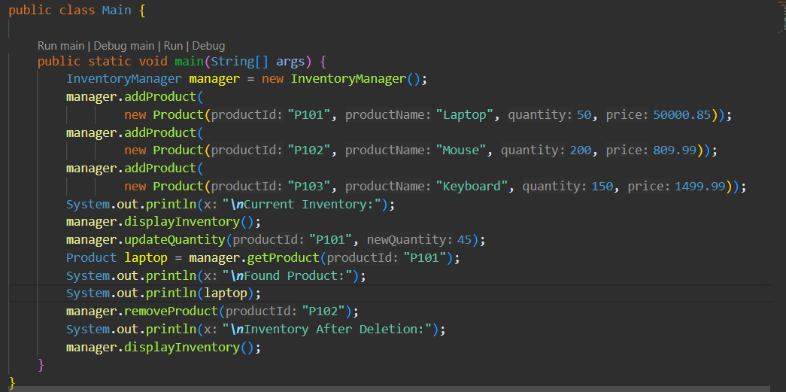

OUTPUT
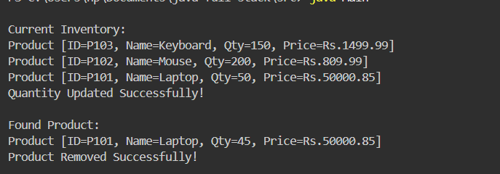
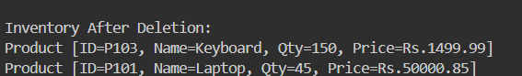

TIME COMPLEXITY ANALYSIS

Operation | Time Complexity
Add Product | O(1)
Search Product | O(1)
Update Product | O(1)
Delete Product | O(1)

